EMAIL ALERTS BY USING PROMETHEUS &GRAFANA
- Go to AWS console
- Launch an ec2 instance by using ubuntu.
( instance type : t3 large , volume 30 gib)
- Connect to the instance and run the following commands
- sudo su
- sudo apt update
- Install docker by using following command.
- apt install docker.io
- install Prometheus, Grafana and Jenkins by using docker by using below procedure
Installation of Prometheus:
- make a Prometheus directory in /home/ubuntu
mkdir /home/ubuntu/prometheus
- configure the file by using following command
nano /home/ubuntu/prometheus/prometheus.yml

# my global config
global:
scrape_interval: 15s # By default, scrape targets every 15 seconds.
evaluation_interval: 15s # Evaluate rules every 15 seconds.
# scrape_timeout is set to the global default (10s).

# Alertmanager configuration
alerting:
alertmanagers:
- static_configs:
- targets:
# Alertmanager's address
#- localhost:9093

# Load alerting rules
rule_files:
# List your alert rules here
- "alert_rules.yml"

# A list of scrape configurations
scrape_configs:
# Scrape configuration for Prometheus itself
- job_name: 'prometheus'
static_configs:
- targets: ['localhost:9090']

# Example scrape config for a Node Exporter
- job_name: 'jenkins'
metrics_path: '/prometheus'
static_configs:
- targets: ['localhost:8080'] # Node Exporter on localhost

- Mention the above configuration in the Prometheus.yml and replace the localhost with public IP
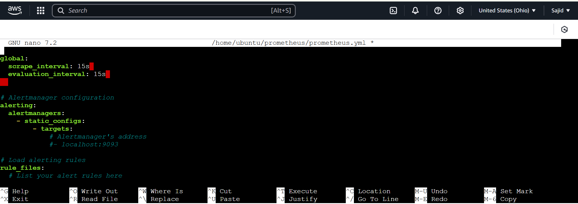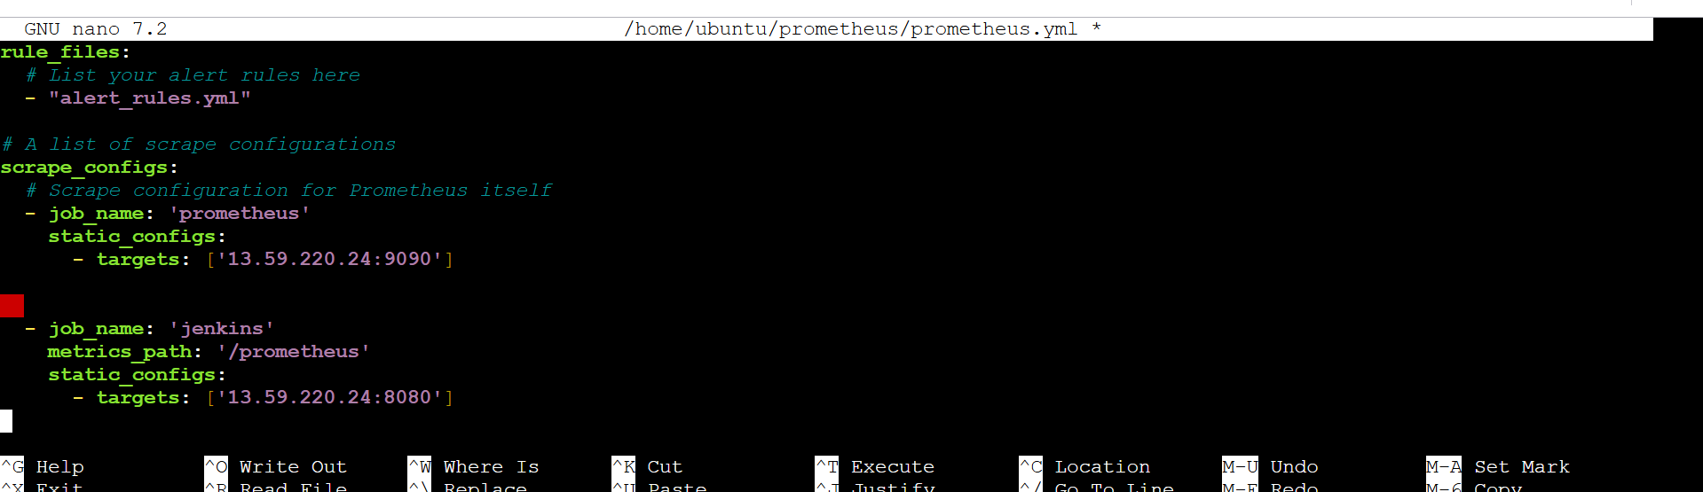
- Save the file using ctrl+X, ctrl+Y and press enter
- Now install the Prometheus by using docker command
docker run -d --name prometheus-container -v /home/ubuntu/prometheus/prometheus.yml:/etc/prometheus/prometheus.yml -e TZ=UTC -p 9090:9090 ubuntu/prometheus:2.33-22.04_beta
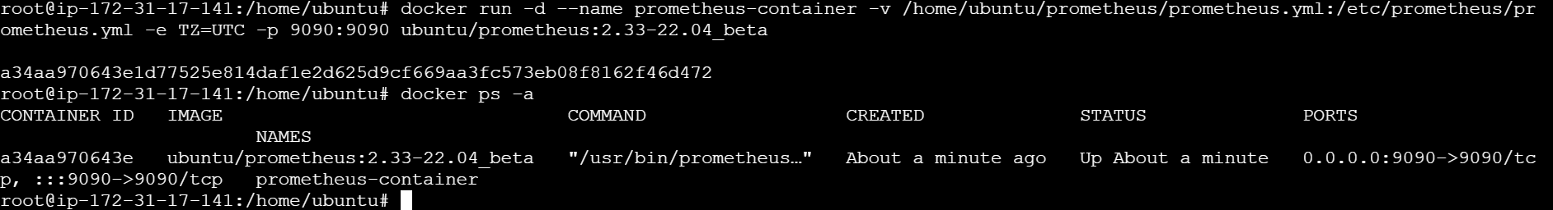

INSTALLATION OF GRAFANA:
- Make a Grafana directory by using following command
mkdir /home/ubuntu/grafana
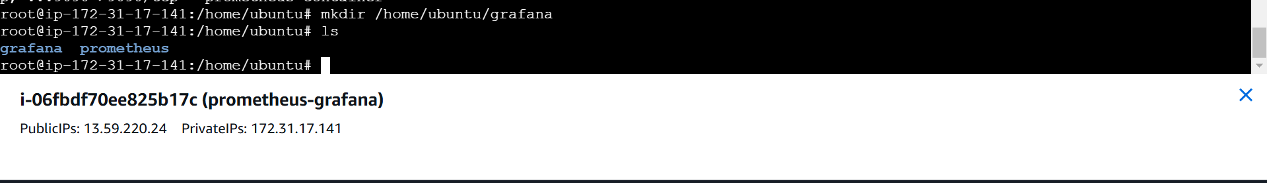
- Configure the file by using following command
nano /home/ubuntu/grafana/grafana.ini
[smtp]
enabled = true
host = smtp.gmail.com:587
user = example@gmail.com
password = <new-password-or-app-password> ( Google account app password)
from_address = example@gmail.com
skip verify = true

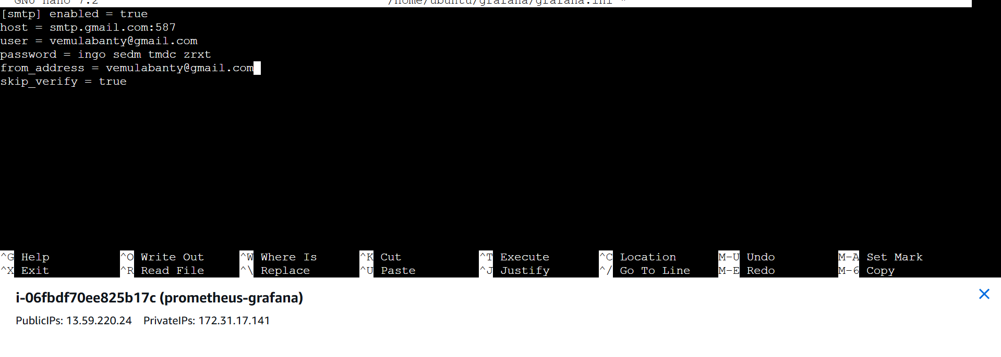
- Save the file using ctrl+X, ctrl+Y and press enter.
- Now install the Grafana by using docker command
docker run -d --name=grafana -p 3000:3000 -v /home/ubuntu/grafana/grafana.ini:/etc/grafana/grafana.ini grafana/grafana:8.5.5
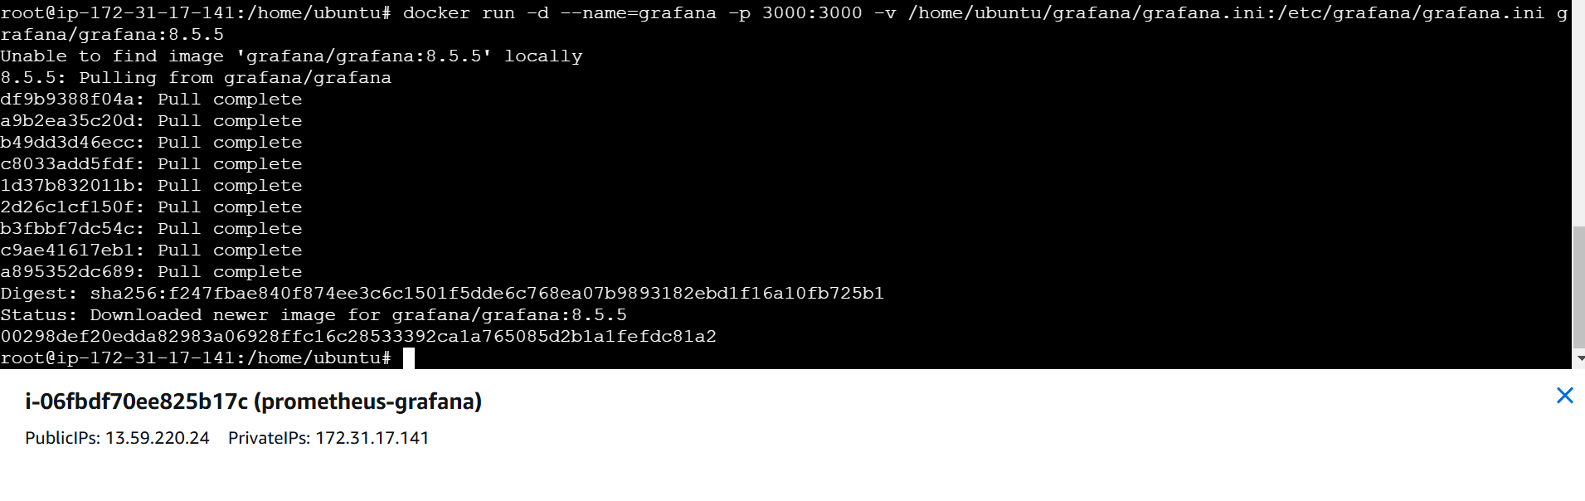
INSTALLATION OF JENKINS:
- Now install Jenkins by using following command
docker run -d -p 8080:8080 jenkins/jenkins:lts-jdk11
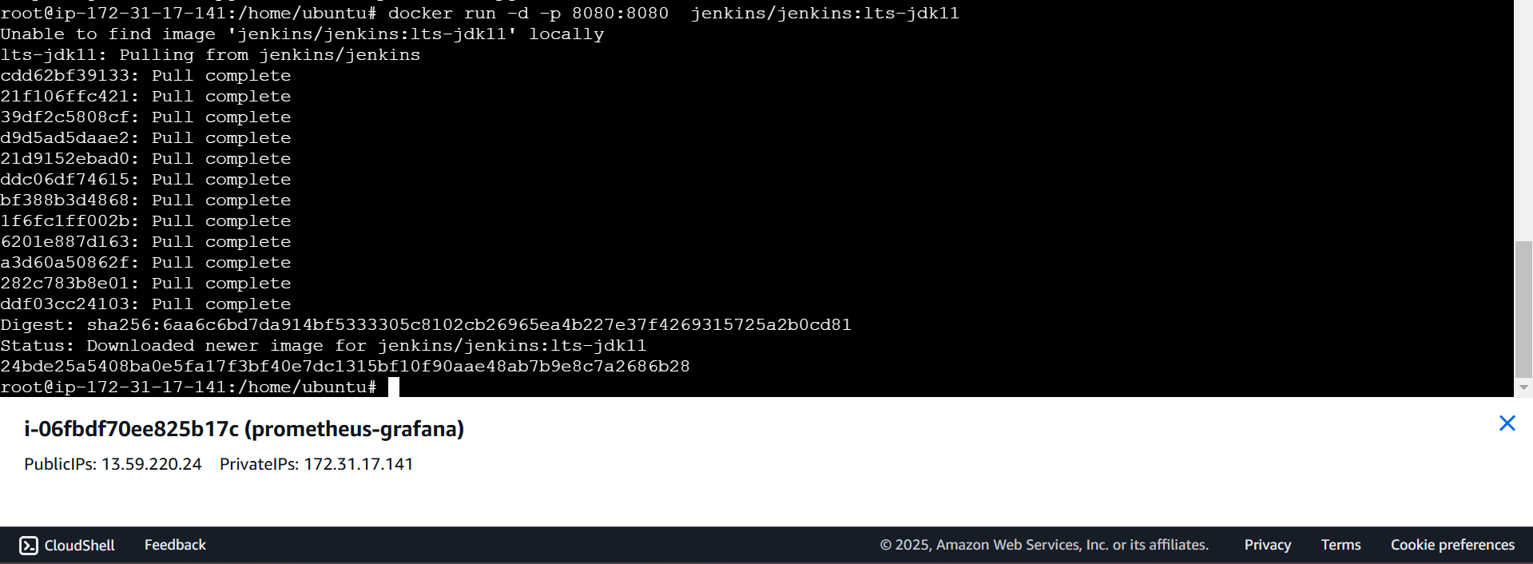
- Add the port numbers in Security groups
- Add the security groups:
9090 (Grafana)
8080 (Jenkins)
3000 (Prometheus)
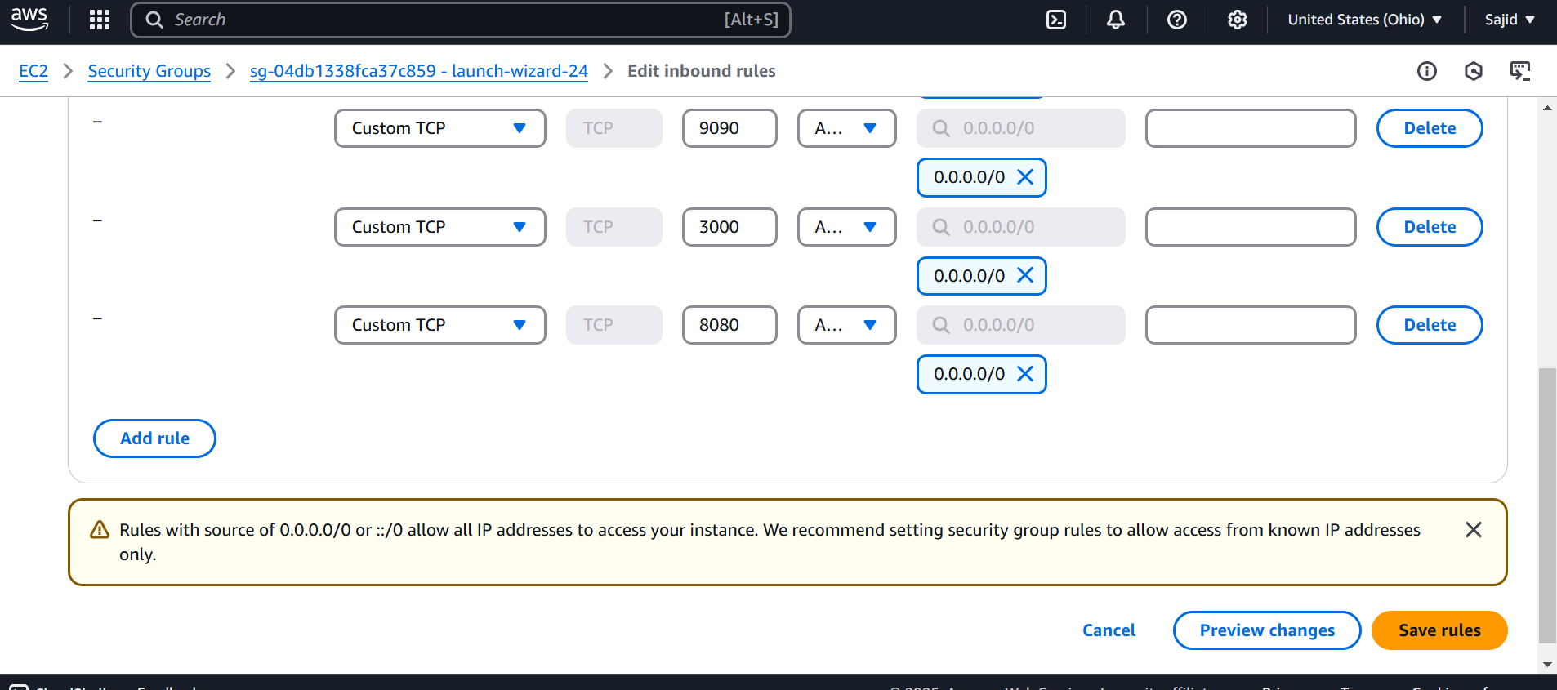
- Connect to the Grafana, Prometheus, and Jenkins.
- Start the Containers of Grafana, Prometheus and Jenkins by using following command.
docker start (Jenkins container ID)
docker start (Grafana container ID)
docker start (Prometheus container ID)
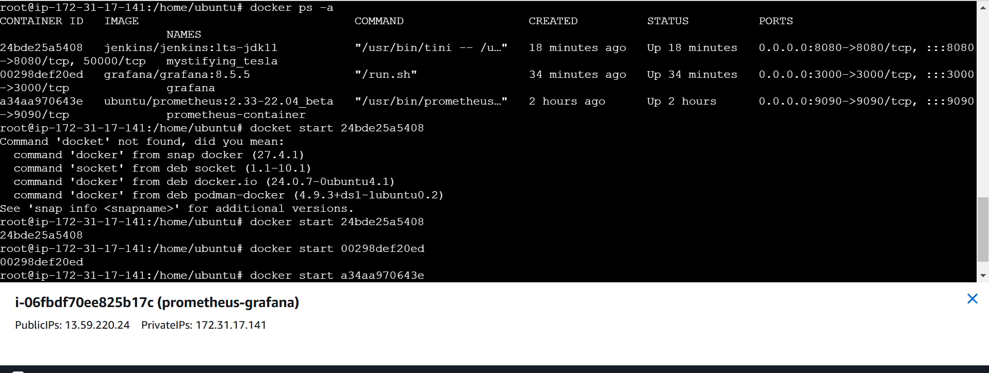
- Now connect to the servers by using IP
- Server IP & port Number - 13.59.220.24:8080 (For Jenkins)
- For Jenkins password we run the following command in server
docker exec < jenkins cont ID> cat /var/jenkins_home/secrets/initialAdminPassword
- After getting into Jenkins dashboard.
- Click on “Manage Jenkins”
- Click on “Plugins”
- Click on “Available Plugins” and install Prometheus metrics & Click on install.
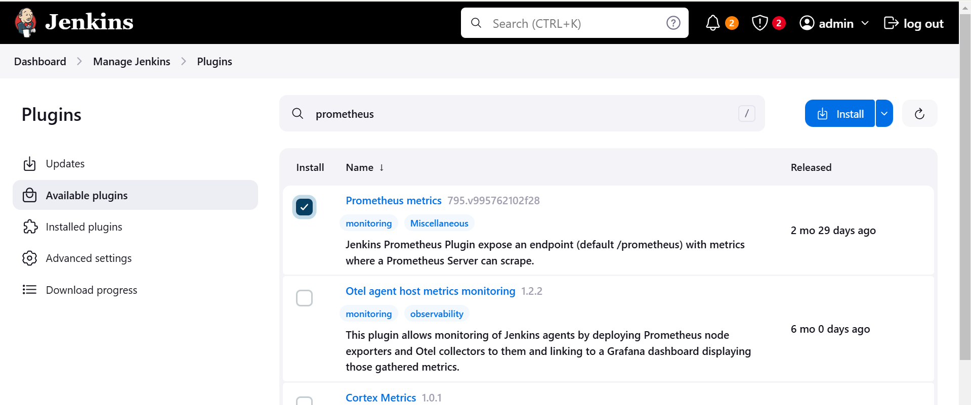
- Now restart the Jenkins
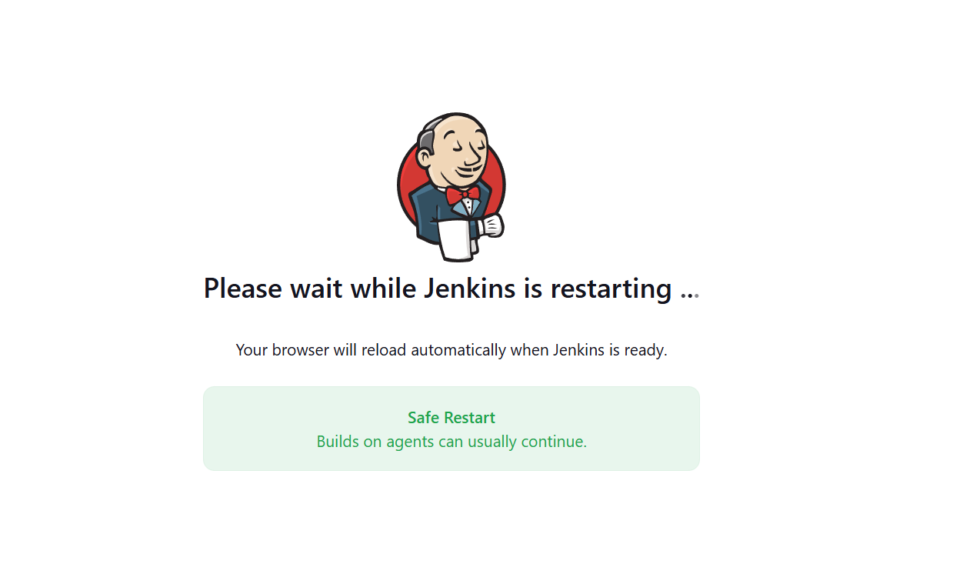
- Server IP & port Number- 13.59.220.24:9090 (For Prometheus)
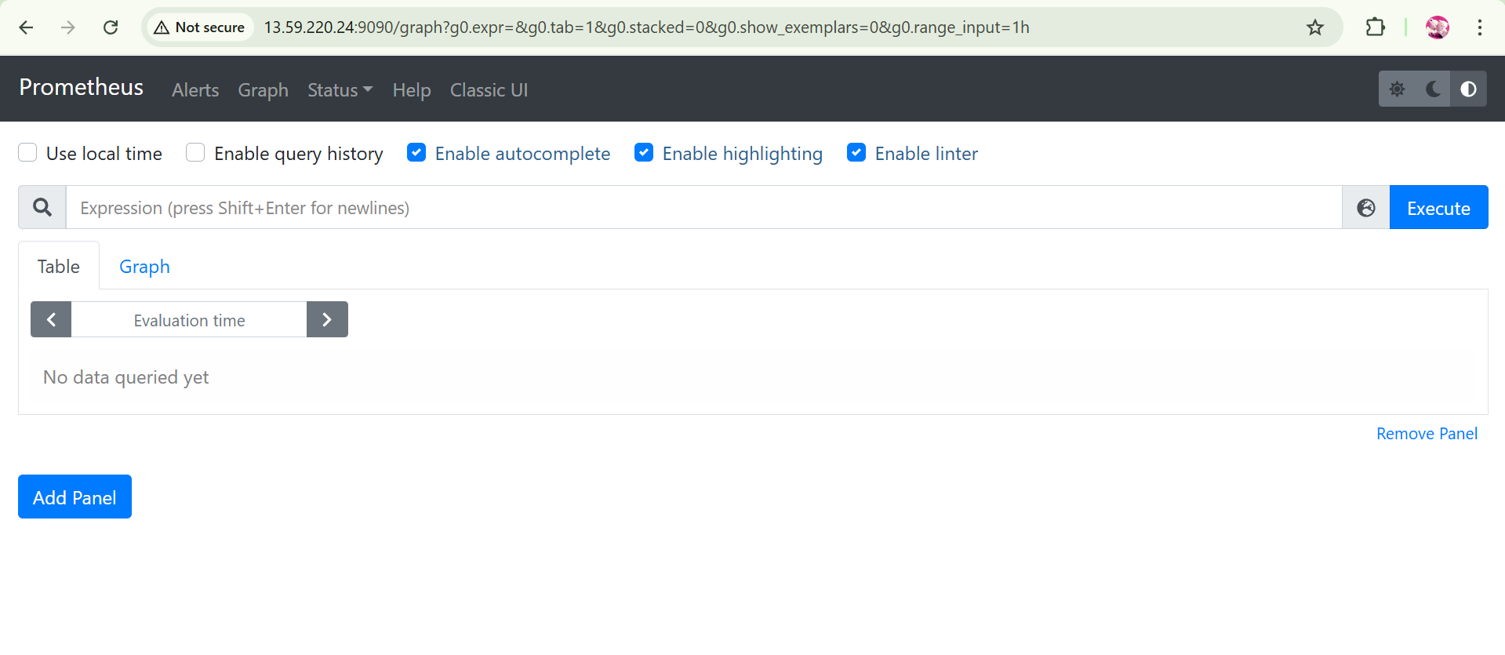
- Refresh the Prometheus page.
- Click on status and then click on targets
- It will show the status of Jenkins and Prometheus
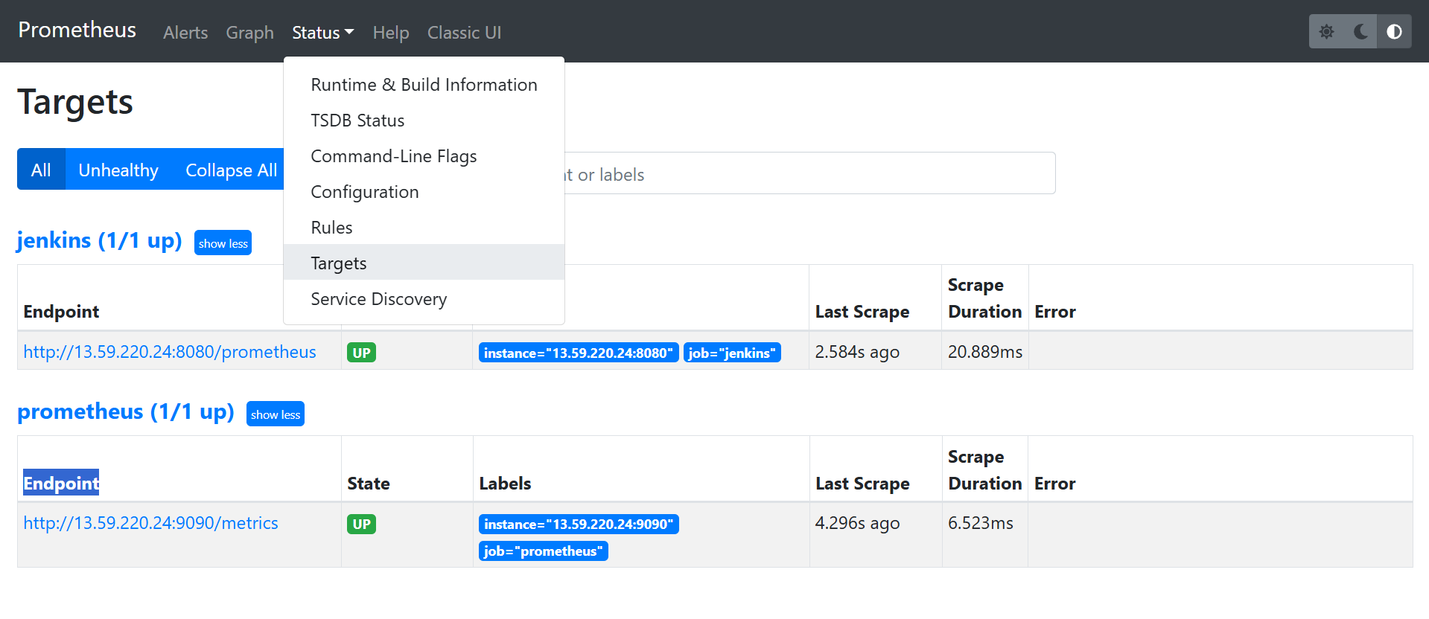
- Now connect to the Grafana by using ip of the server
Localhost(public IP):3000
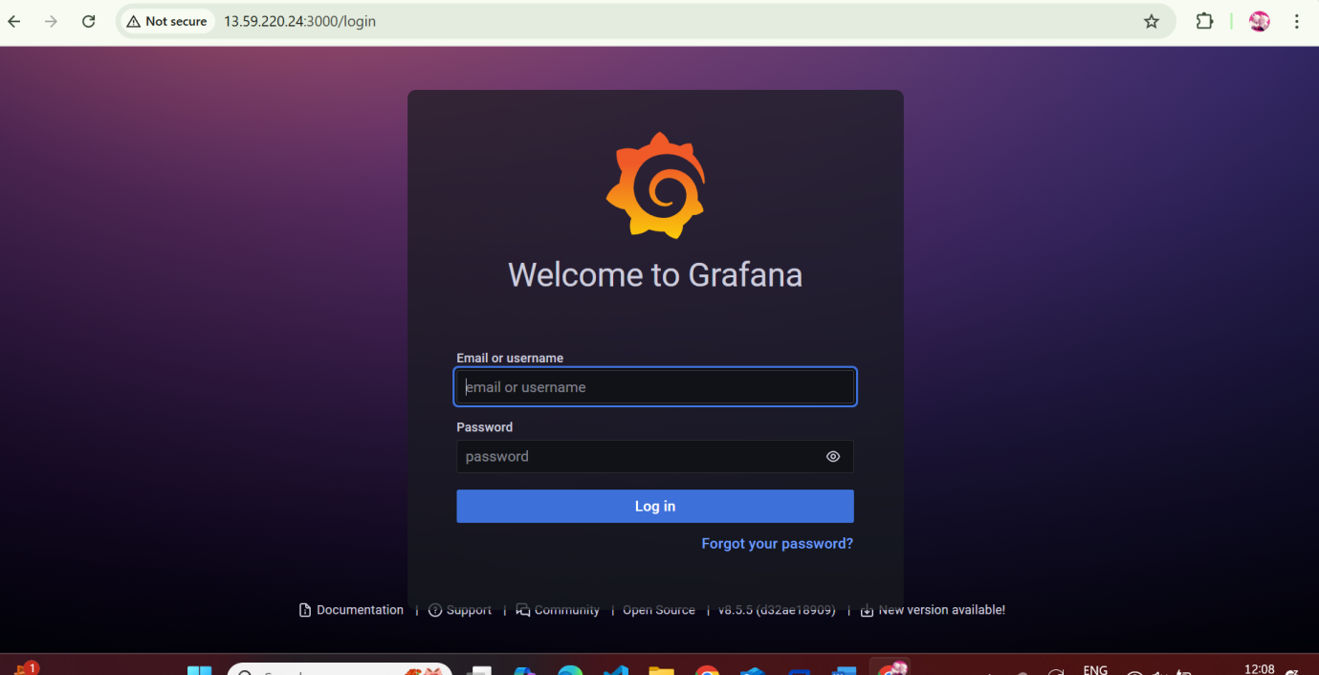
- Create user and password
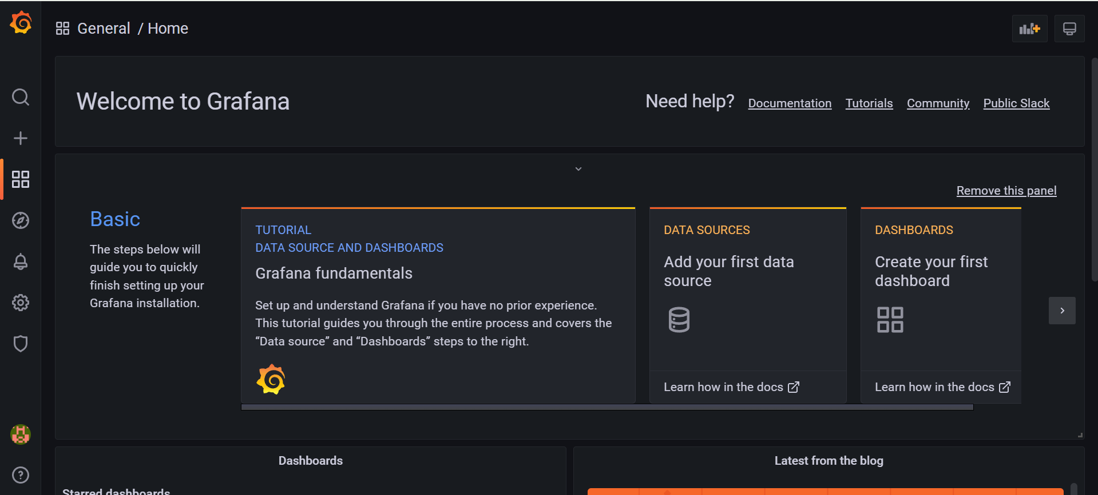
- Click on data sources
- Click on Prometheus
- Give the url of the Prometheus
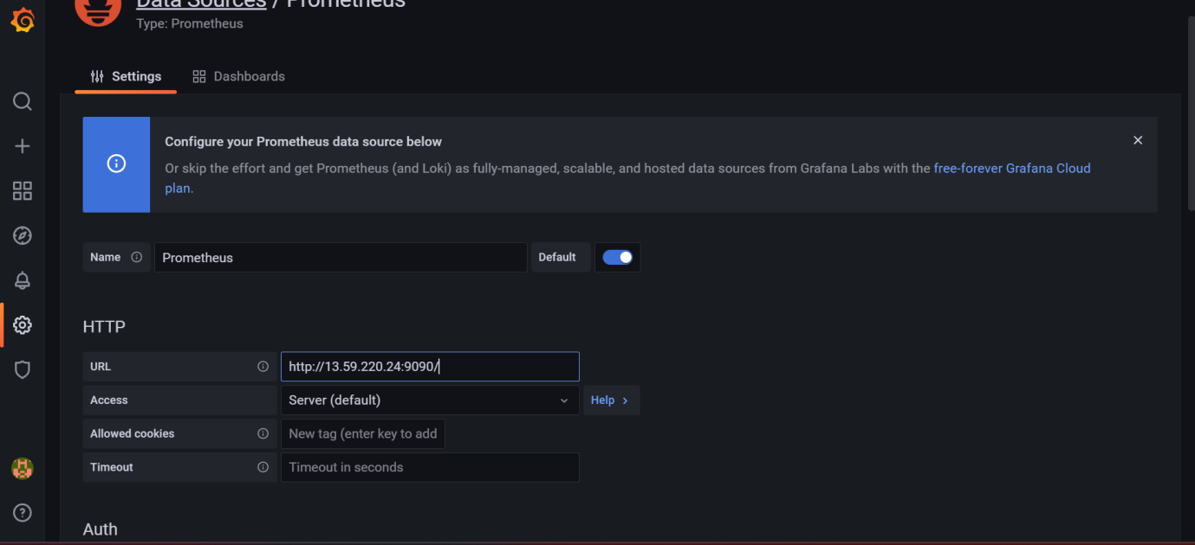
- Click on save and test
- Now go to home page and click on dashboard
- Click on add a new pannel
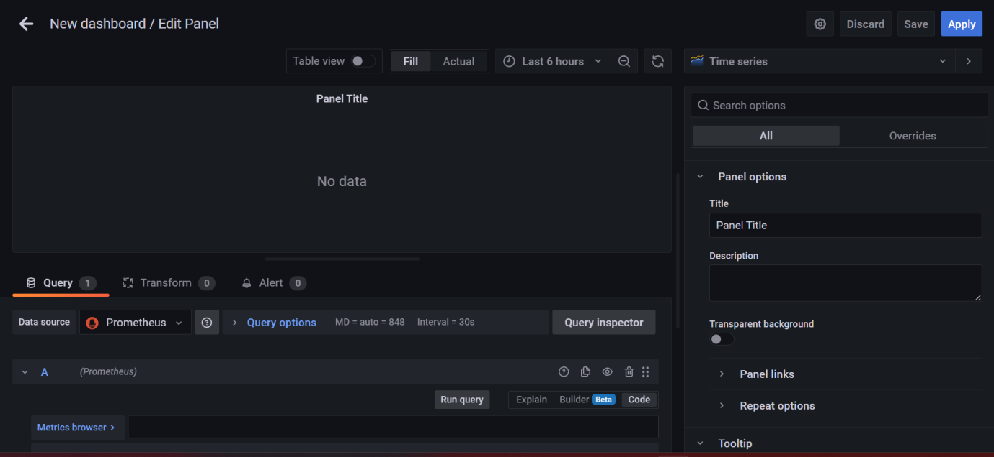
- In the metric browser we need to search the required query.
- And click on use query.
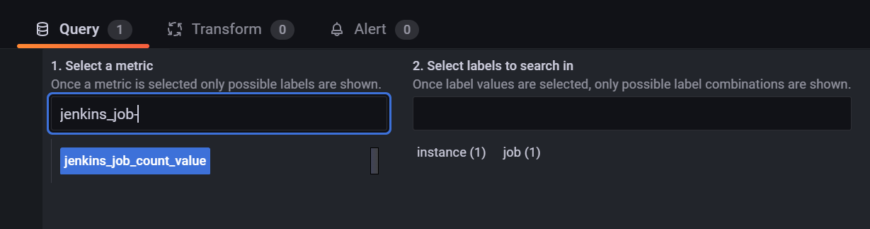
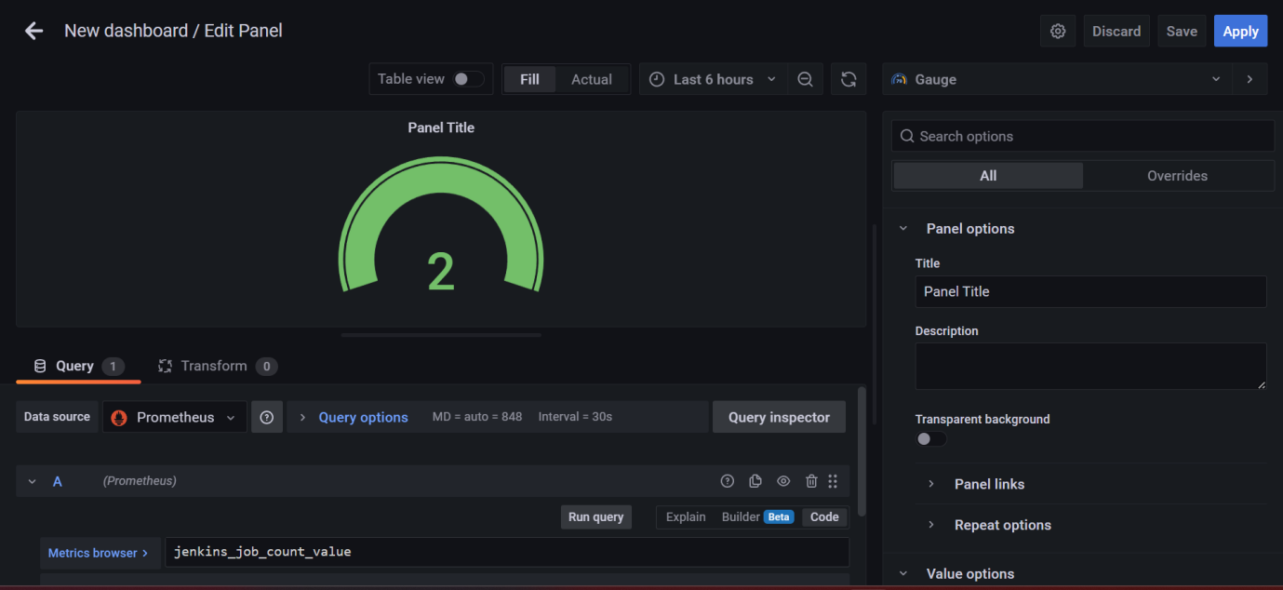
CREATION OF EMAIL ALERT RULE FOR JENKINS
- Now go to the dashboard and click on + symbol and click on folder
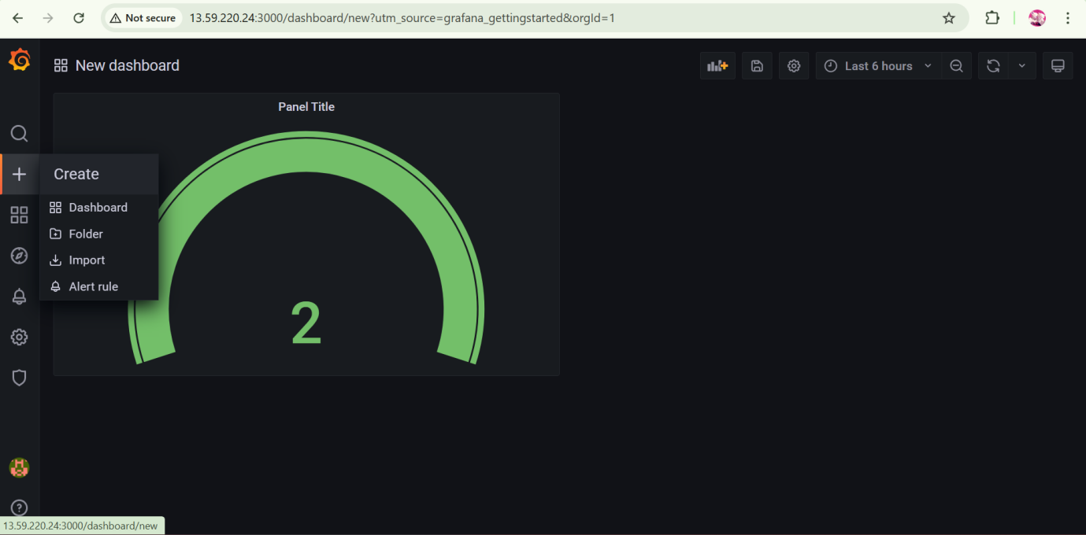
- Give a name to the folder and click on create.
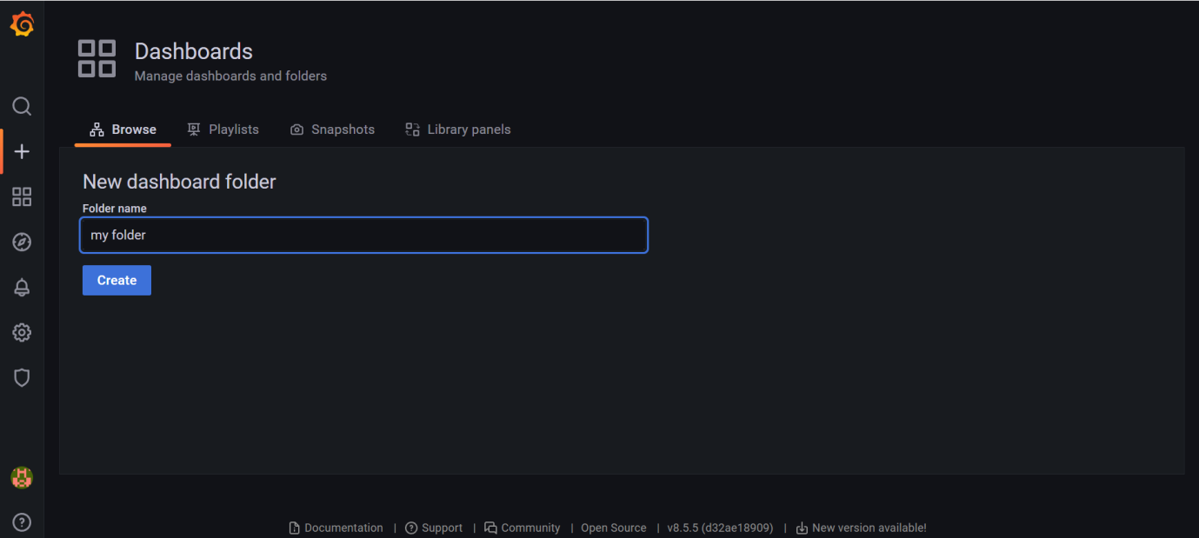

- Click on alerting rules and create the alert rule
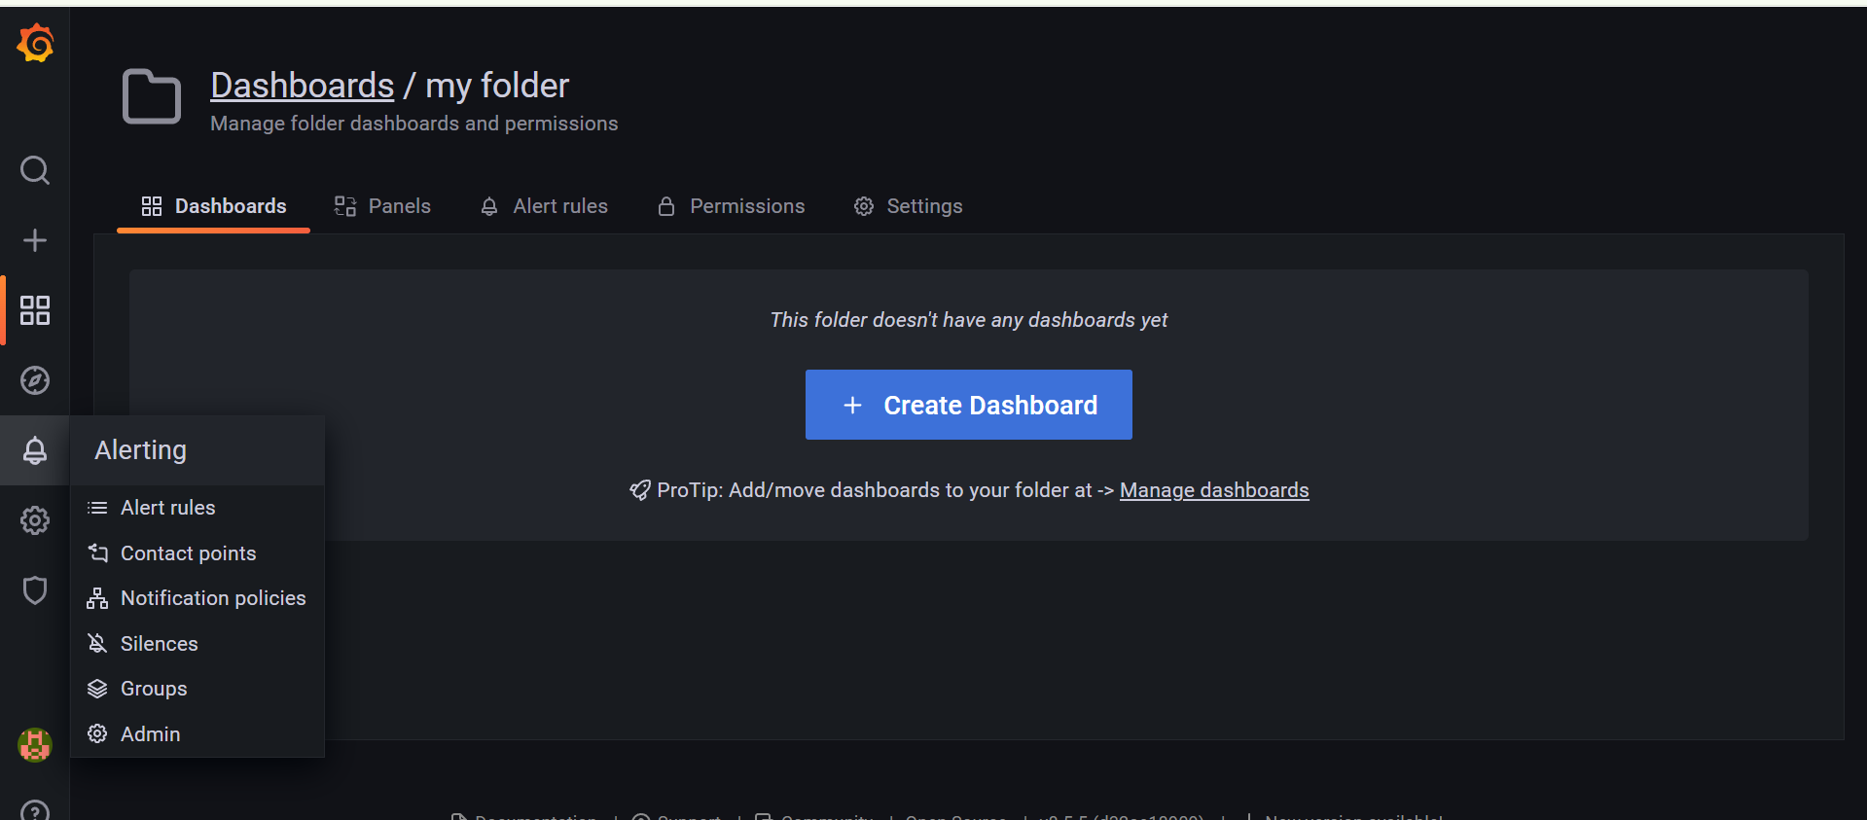
- Click on new alert rule
- Give a role name
- Store the rule in created folder and create a group
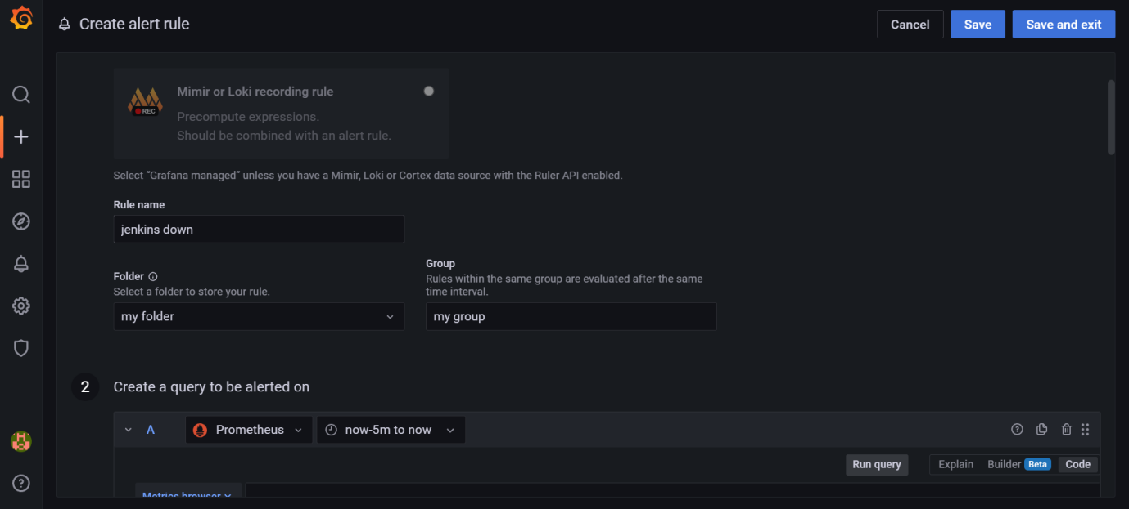
- Search your query in metric browser
- Select your reqired query and click on use query
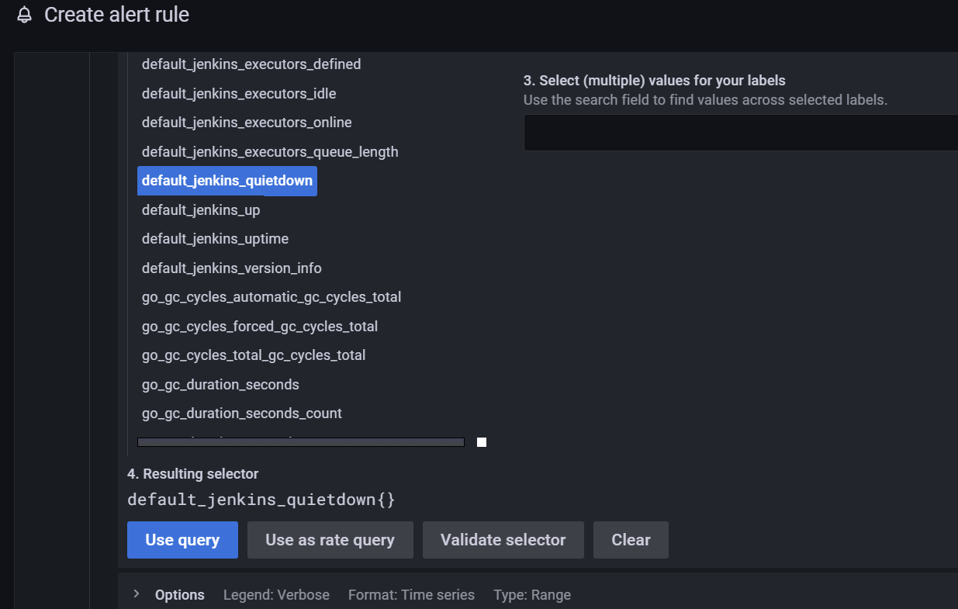
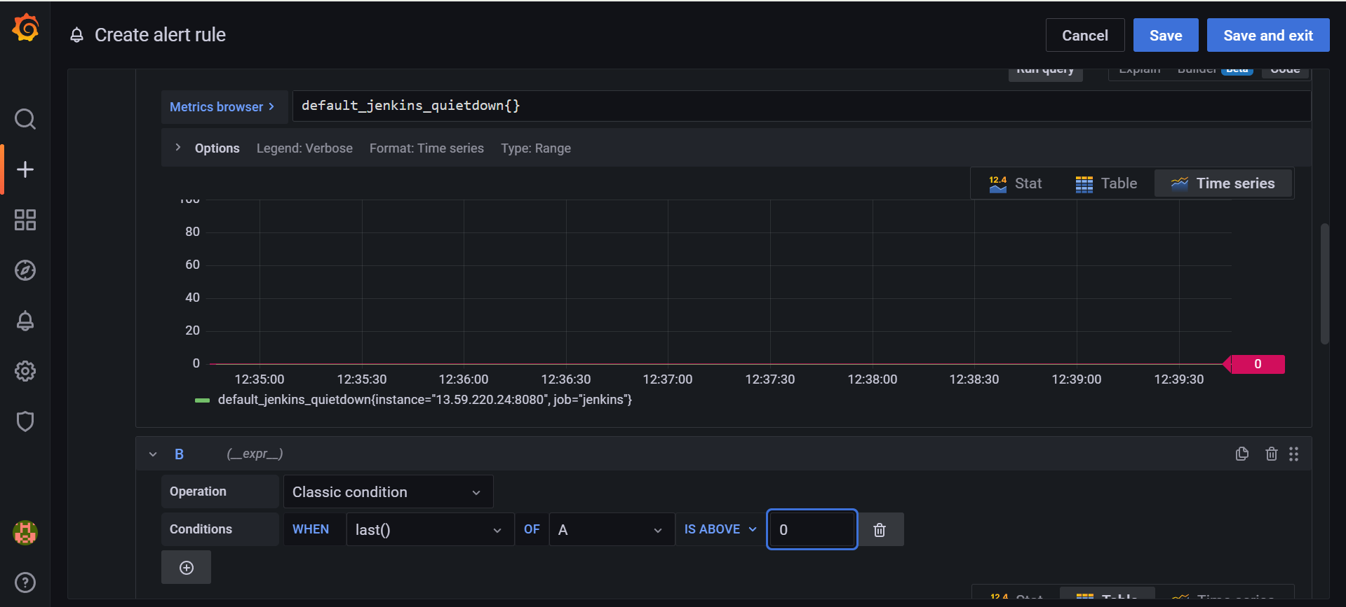

- Define your alert conditions
- And click on save.
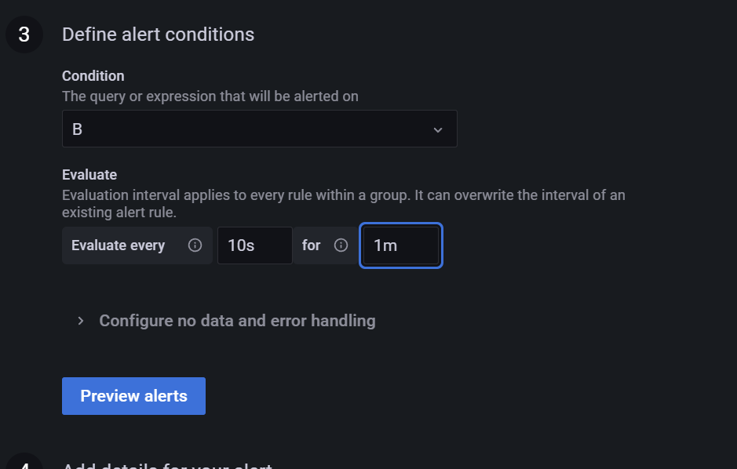
- If the Jenkins server will down we will get email notification
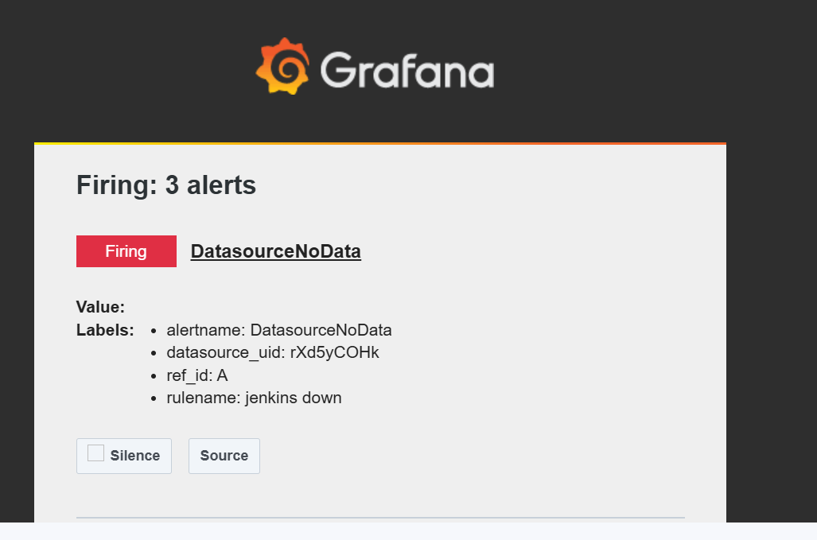
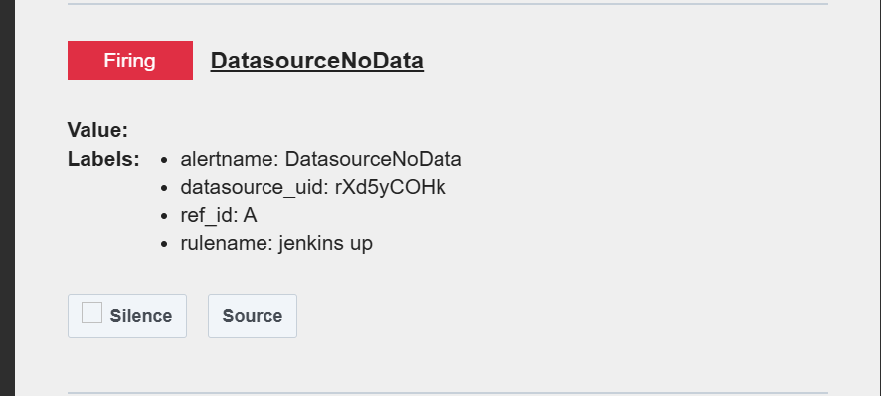

INSTALATION AND CONFIGURATION OF NODE EXPORTER FOR CPU UTILIZATION
- Install the node exporter using following command
docker run -d --name=node-exporter \ --restart=unless-stopped \ -p 9100:9100 \ quay.io/prometheus/node-exporter:latest
- Configure the Prometheus file add the fallowing details
nano /home/ubuntu/prometheus/prometheus.yml

# Scrape Node Exporter metrics
- job_name: 'node-exporter'
static_configs:
- targets: ['public ip:9100']
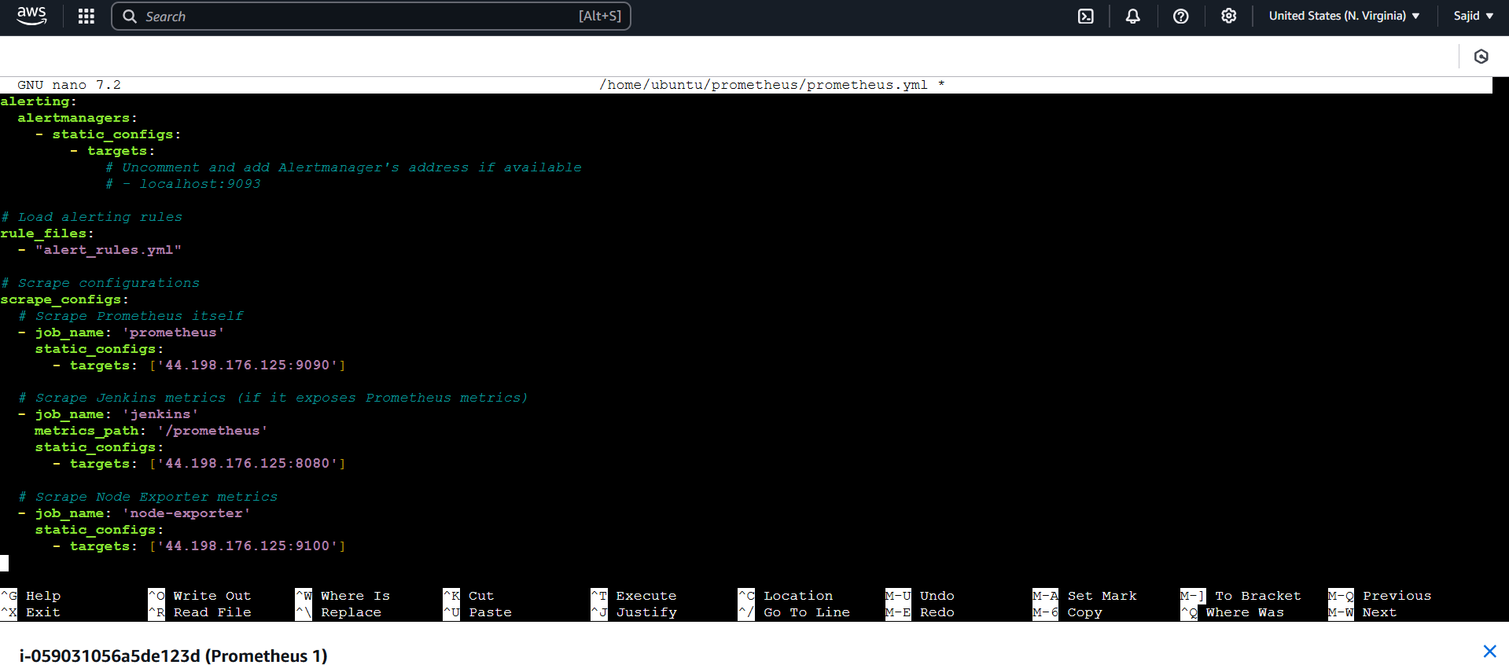

- Save and quit the file
- Add the 9100 port in security group of instance
- Restart the Prometheus
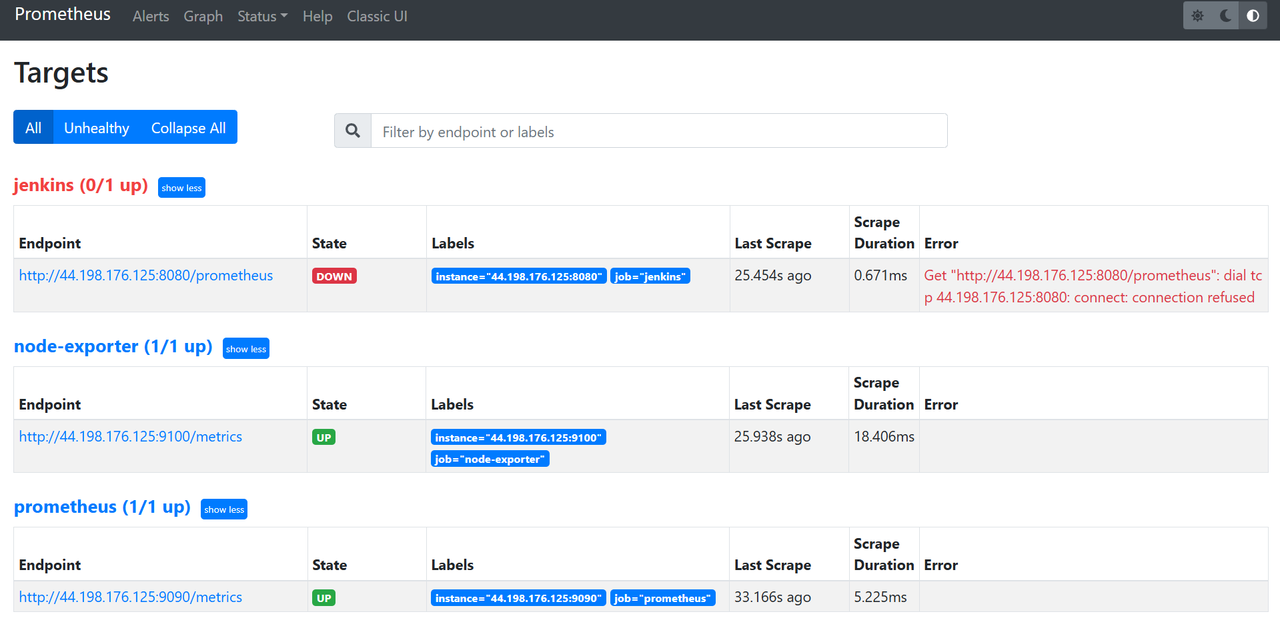
- Go to the Grafana dashboard
- And browse the metrics to know the cpu utilization
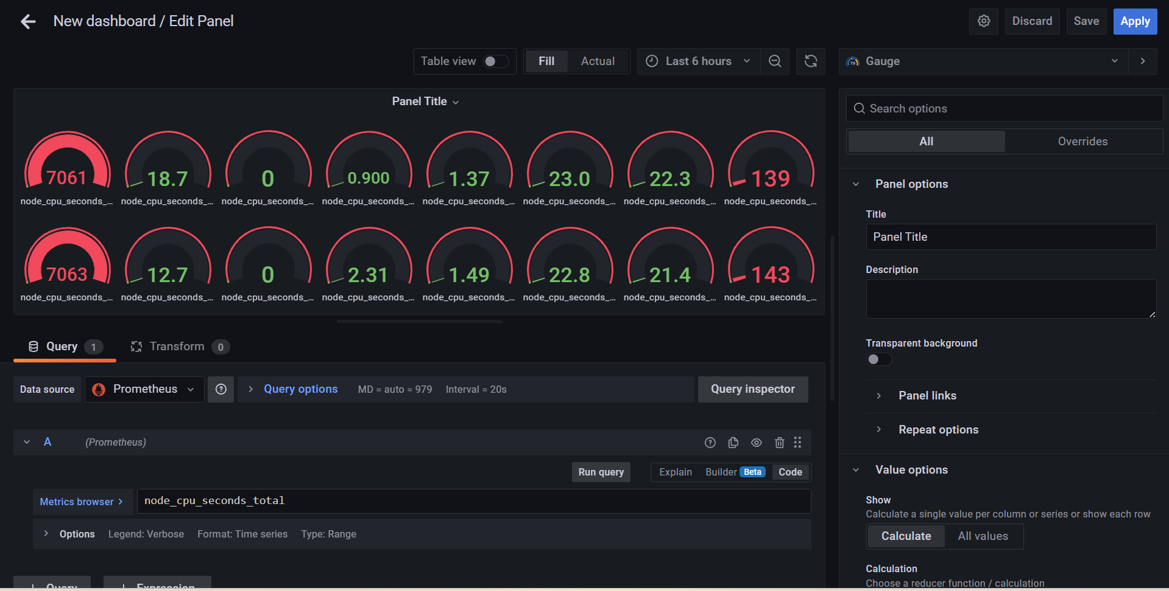
- If we need to import a dashboard click on import and specify the id and click on load
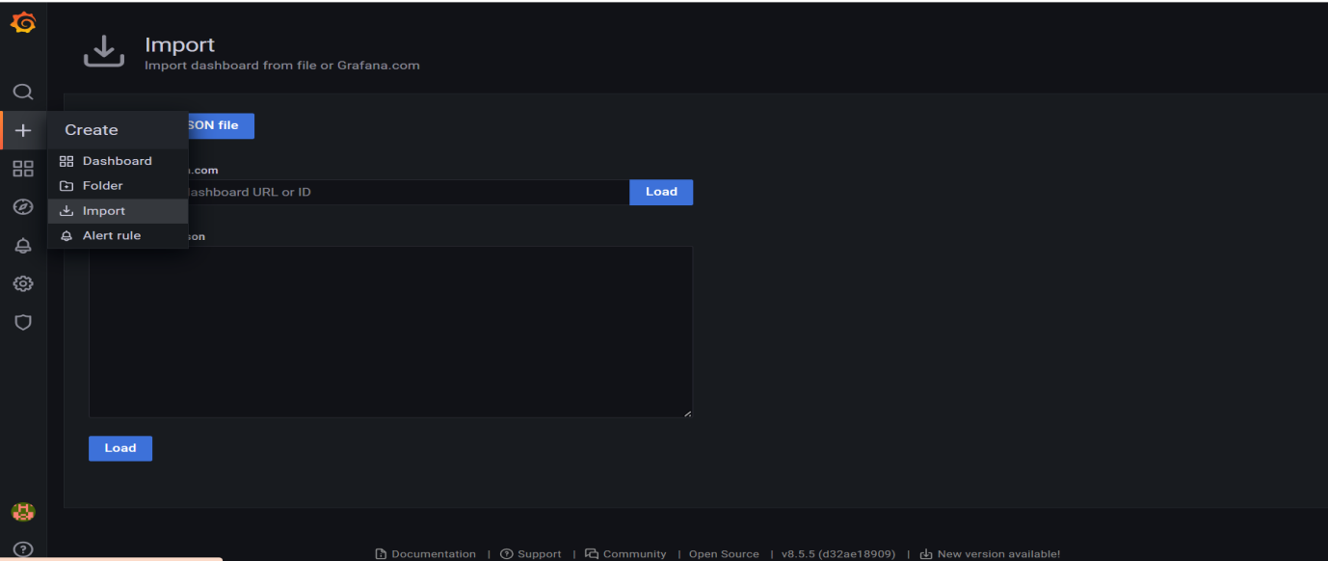
- Eg : 11074 (if we specify this id we get dashboard as below)
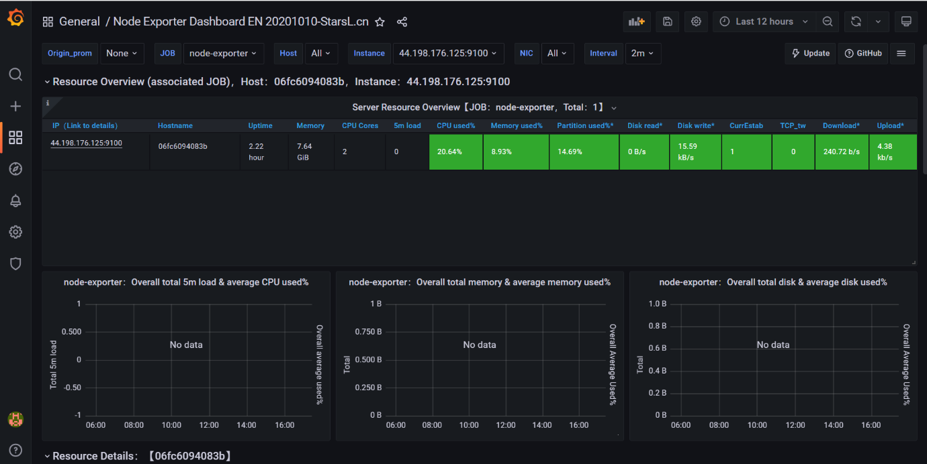
Use the Node import ports to load the server (search in chatgpt)
1806

